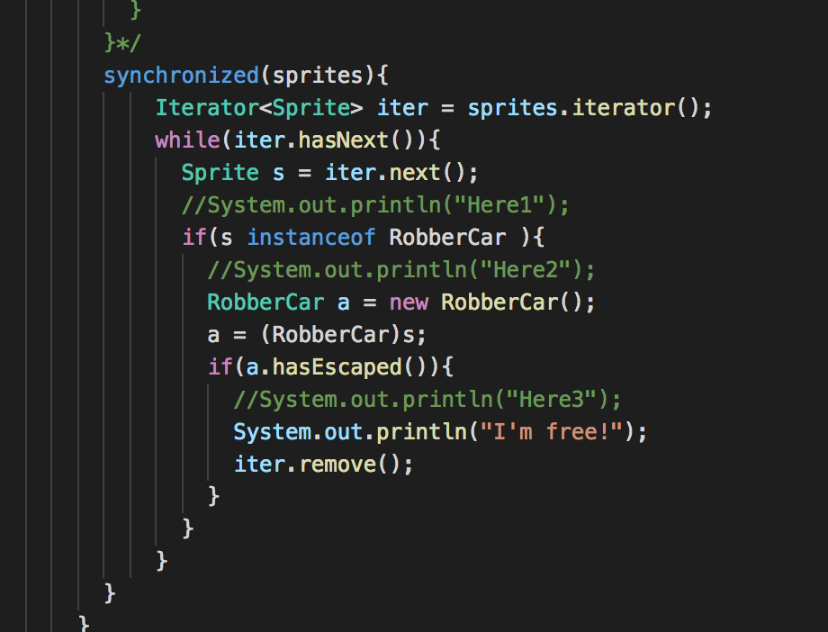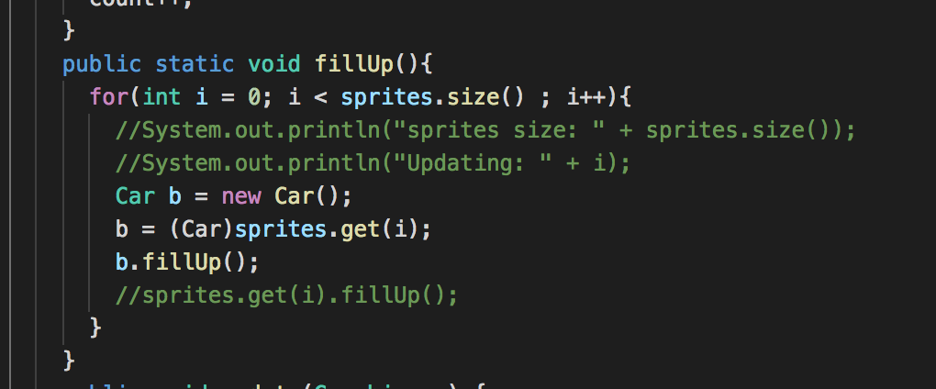

* Variable vs object - My house itself is like an object. I can give out multiple references to the same object, but there's only one object, BUT A variable is like a piece of paper. It holds a value, but it isn't the value in itself. You can cross out whatever's there and write something else instead.

Instantiating an object - is the creation of a real instance or particular realization of an abstraction or template such as a class of **object**s – use the operator new ie: Person Teagan = new Person();

Variable TYPES – primitive and reference

Jvm – virtual machine that enables computers to run java programs

Bytecode – the code that is compiled to be ran on a jvm

Main – where each program starts public static void main(String[] args)

Void – no return type

Constructor – Same name as class, can take parameters

Default constructor – only get if you don’t make a constructor, initializes instance variables to 0 or false, calls super constructor

Import – import an entire packaged #include in CPP

Primitive – 8 types (Boolean, byte char short int long float double)

Reference – instantiable class as well as array (int[], String, Scanner…)

Local – only visible within the block of code it declared in

Instance – declared outside methods but are object specific

Object – the root of inheritance in java, everyone has it

Extends – can only extend one class

Implements – can implement as many interfaces (runnable )

Class –

Super – the parent class of a certain class can use super.

toString – every class inherits this from Object

overloading – creating same methods with different parameters

polymorphism – is-a relationship

instanceOf – test whether object is instance of a type (Robber is Car, but car isn’t robber )

shadowing – 2 variables same name, the more specific is used, more general is shadowed

interface –

adapter –

abstract –

final – variables cant be changed like PI in the math class

static – can be accessed with name of the class, stay the same over all instances of the class

generic -

